Project 1: Submission

Deploy a People Counter App at the Edge - Write-Up

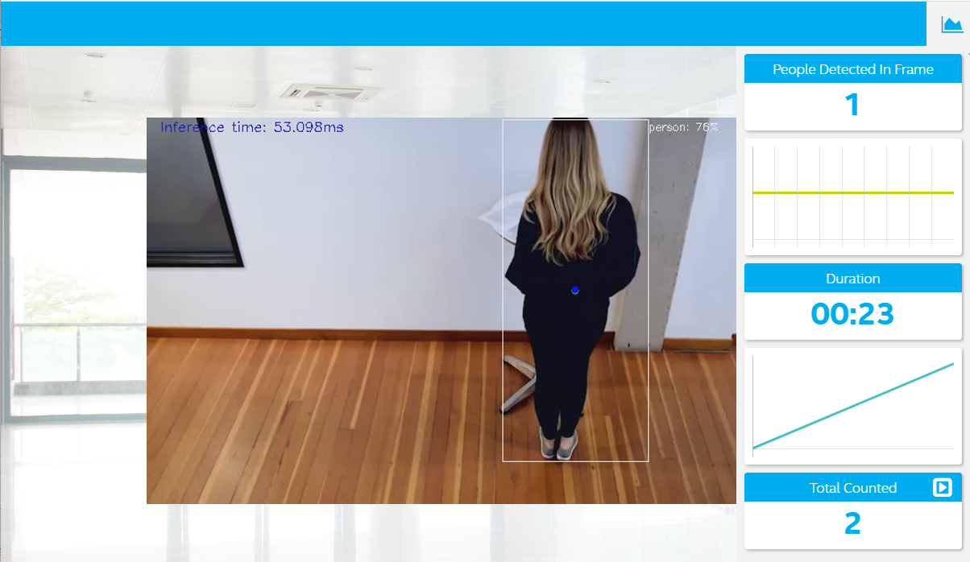

*Due Date: May 26, 2020*

*By: Reginald Cobb*

**Table of Contents**

Project 1: Deploy a People Counter App at the Edge 3

Project Introduction 3

Explaining Custom Layers 3

What is a Custom Layer 3

Identifying Custom Layers 3

Custom Layer Processing 3

Converting Custom Layers 3

Reasons for Handling Custom Layers 4

Comparing Model Performance 4

Before and After Conversion to Intermediate Representation 4

Size Comparison 5

Inference Time Pre- and Post-Conversion 5

Pre- and Post-Model Conversion Performance 5

Size of Model Pre- and Post-Conversion 5

Assess Model Use Cases 5

Assess Effects on End User Needs 6

Additional Model Research 6

# 

# Project 1: Deploy a People Counter App at the Edge

## Project Introduction

### Command used to Run Solution

python main.py -i resources/Pedestrian_Detect_2_1_1.mp4 -m example/MobileNetSSD_deploy.xml -l /opt/intel/openvino/deployment_tools/inference_engine/lib/intel64/libcpu_extension_sse4.so -d CPU -pt 0.6 | ffmpeg -v warning -f rawvideo -pixel_format bgr24 -video_size 768x432 -framerate 24 -i - http://0.0.0.0:3004/fac.ffm

This project is a demonstration of a People Counter that detects people in the area of the video and collecting metrics for

* Number of people in each frame of the video at a given moment
* Average duration of the people in frames of the video (I changed this to the Duration.)
* Total Count of people appearing in the video (as defined as a person entering and exiting the video before another person enters the video.)

The application also evaluates the use and advantage of Intel software tools

## Explaining Custom Layers

### What is a Custom Layer

The Intel OpenVINO tools supports neural model layers for major frameworks. Each of the supported frameworks use “layers” to perform special purpose (relu, sigmoid, tanh, convolutional, etc.) calculations to sequentially build a neural network. Since each framework can supports a unique and different set of layers, any layers not natively supported by the OpenVINO toolset must be implemented as a custom layer.

#### Identifying Custom Layers

The OpenVINO toolkit supports a specific set of layers. If the model uses a layer that is not supported natively in the toolkit, e.g. unsupported, then that layer is said to be “unsupported” and the toolkit will report an error to the user.

#### Custom Layer Processing

Layers are processed by the Model Optimizer (MO) component of the toolkit. The MO uses topology information from the input model for each layer to build an optimized model that is used by other parts of the toolkit.

#### Converting Custom Layers

Any custom layer implemented for models need to enable two extensions in the MO and subsequent downstream processing: the Custom Layer Extractor and the Custom Layer Operation.

The [OpenVINO Toolkit Custom Layer Guide](https://docs.openvinotoolkit.org/latest/_docs_HOWTO_Custom_Layers_Guide.html) provides the overview diagram below, but in summary the MO extracts information from the input model, then the model is optimized based on that information. The optimized model serves as input for further downstream processing.

#### Reasons for Handling Custom Layers

A primary reasons for handling custom layers are to include specific processing in a model.

## Comparing Model Performance

### General Performance Impacts

In general, different modeling parameters could have been selected to solve this problem. A different model could have been used that require larger data elements, e.g. 32 bit vs 8 bit, processor, CPU, GPU, etc., or transfer of data between sub-sections of the system, e.g. display images to a screen or send video files for storage. These decisions could increase requirements of the network used to connect components or transfer information and also impacted any cloud hosted solution by requiring more storage or compute resources.

Especially when considering deploying devices on the edge or IOT devices. Most edge or IOT devices are limited in processing power, storage and interfaces. Also, in most cases, these devices also have form-factor, environmental or power limitations that could make it impossible to be upgraded or provide increased processing. Careful consideration should be used when evaluating parameters and the impact on the design and performance of a system.

### Other Performance Considerations

As described below, I developed two Python scripts that implemented the pre- and post-conversion models.

### Initial Double Counting Problem

One of the initial problems was the fact that the model had intermittent frames where the person was not identified. While this did not affect the ability to correctly collect metrics, there was a problem with double counting people. To help avoid this problem, I implemented a centroid tracking algorithm on the current and previous position and used it to identify if a person was new if their current centroid was significantly different than the previous’ frame person centroid.

### Before and After Conversion to Intermediate Representation

To compare model performance before and after conversion to Intermediate Representations, I chose not to use the python script developed for Project 1 because it has MQTT, counters, time calculations, and other processing that while beneficial to the project’s objective, would hinder an apples to apples comparison. So I chose to simplify the activity and base my model comparison after the work on a webpage by dyan Mendez located at [this link](https://ebenezertechs.com/mobilenet-ssd-using-opencv-3-4-1-deep-learning-module-python/). .

I created two python scripts to evaluation performance and both are included in the zip file and github repository for Project 1 submission

* mobilnet_ssd_python.py
  + This python script contains the MobilNet-SSD object detection for the Caffe deep learning framework. The script uses the OpenCV Deep Neural Network (DNN) module. The model is converted includes a mean subtraction to normalize the inputs
* mobilnet_ssd_python_OpenVINO.py
  + This python script uses the MobilNet-SDD object detection model for the Caffe framework but with the model converted to Intermediate Representation before inference is performed.

### Size Comparison

|  |  |
| --- | --- |
| **Model Size Comparison** | |
|  | ***MobileNetSDD*** |
| **Pre-Conversion** | 22.6MB |
| **Post-Conversion** | 22.6MB |

### Inference Time Pre- and Post-Conversion

|  |  |
| --- | --- |
| **Inference Times** | |
|  | *MobileNetSDD* |
| **Pre-Conversion** | 41.7 ms |
| **Post-Conversion** | 41.1 ms |

## Size of Model Pre- and Post-Conversion

|  |  |  |  |
| --- | --- | --- | --- |
| **Model Size Comparison - Caffe Implementaiton** | | | |
|  | ***Google MobileNet v1*** | ***Google MobileNet v2*** | ***MobileNetSDD*** |
| **Pre-Conversion** | 16.6MB | 13.8MB | 22.6MB |
| **Post-Conversion** | 16.4MB | 13.6MB | 22.6MB |

## Assess Model Use Cases

This people counter could be repurposed for many other purposes. A few are mentioned below…

### Retail Area Monitoring

A retailer could use the application to count the number of customers who enter sections of their establishments or specific areas, like a product display. This could be used to gauge areas of interests that the retailer could use to fine tune their offering, traffic flow, etc.

### Airport Sensitive Area

At airports of all sizes in the United States, there are areas that are either off limits, e.g. count should always be zero, or only a limited number of people are allowed to be in area throughout the day.

### Entrance/Exit Monitoring

The application could be used to monitor the number of people who use entrances and exits. For instance, I worked at a manufacturing and we had an incident where an employee returned after hours and stole some equipment. That and other reasons, required us to install doors that only allow one person to enter/exit at a time. But in case of emergency, we had exits doors that opened. The people counter could be used to count the people who exit those doors.

Or it could be used to supplement a home security system that monitor the gates to the back yard or pool and provide notification based on count logic

### Military Recruit Monitoring

I am a retired military man and during our recruit training, there were many places in our barracks that the recruits either could not go during certain times of the day, i.e. the bathrooms are off limits at certain time for the safety of the recruits, or the locker where we stored gear could only have two people in it at one time. The counter could either be tied into a notification system to buzz or light up when certain parameters are exceeded.

## Assess Effects on End User Needs

Lighting, model accuracy, and camera focal length/image size have different effects on a

deployed edge model. The potential effects of each of can cause the model to infer the wrong shape for models, the classify wrong edges and be thrown off by contrast or gain or level pixels.

Also, these effects could increase the amount of data required by the model, e.g. larger image sizes increase the network bandwidth needs and increase the complexity and costs of a design, camera focal length could increase either the amount of detail in an image or the amount of information included in an image. Both could increase the bandwidth requirement and data storage needs which could increase costs. And the lighting could lead to difficulties in object recognition which could require additional process to achieve satisfactory results.

I think the final area of impact would be the system performance because an increase in either available data, e.g. higher res or larger images, higher accuracy, e.g. 32 bit vs 16 bit, or lighting, which could lower the object detection accuracy and require additional processing. All of these might require a more power processing system, additional system resources, i.e. memory or additional system needs, cooling or footprint. All of these could affect costs or satisfaction with the system.

## Additional Model Research

I used the MobileNetSDD model for this project. I converted the model (and based on research adjusted for mean values) to an Intermediate Representation with the following arguments…

MobileNetSDD

python /opt/intel/openvino/deployment_tools/model_optimizer/mo.py --input_model MobileNetSSD_deploy.caffemodel --input_proto MobileNetSSD_deploy.prototxt --mean_values [127.5,127.5,127.5] --scale_values [127.5]

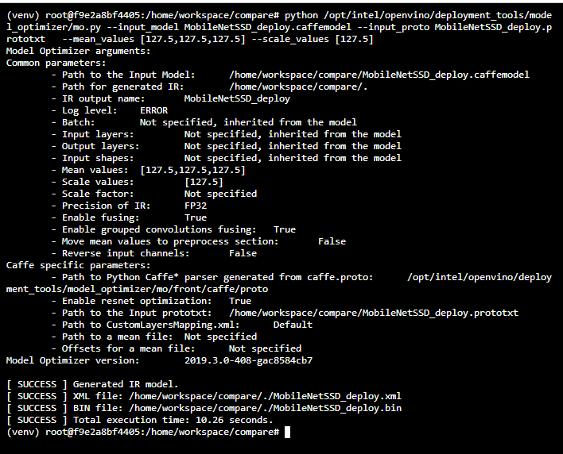

Mobilenet v2

python /opt/intel/openvino/deployment_tools/model_optimizer/mo.py --input_model mobilenet_v2.caffemodel --input_proto mobilenet_v2_deploy.prototxt   --mean_values [127.5,127.5,127.5] --scale_values [127.5]

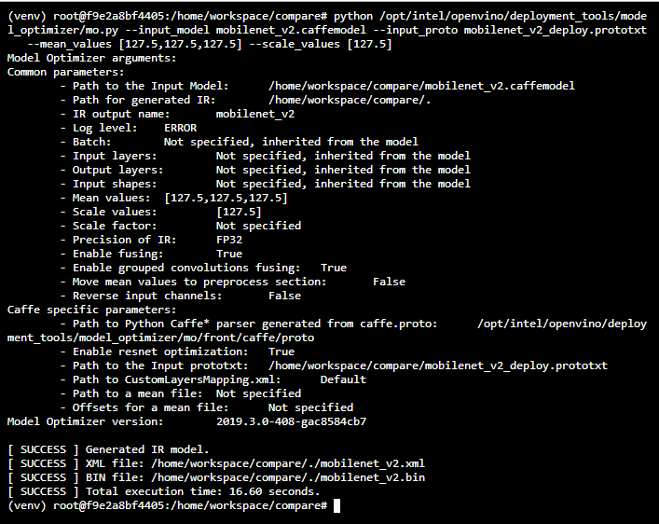

Mobilenet v1

python /opt/intel/openvino/deployment_tools/model_optimizer/mo.py --input_model mobilenet.caffemodel --input_proto mobilenet_deploy.prototxt   --mean_values [127.5,127.5,127.5] --scale_values [127.5]

